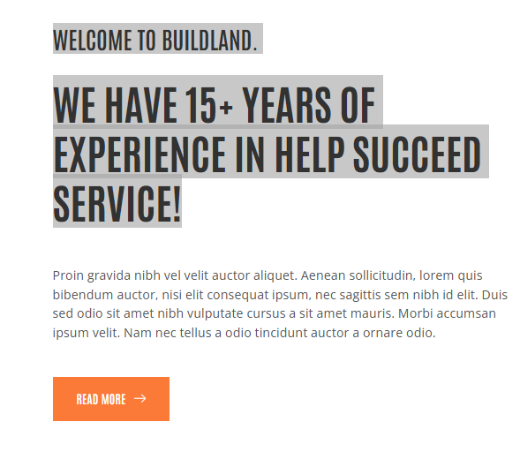
Welcome to MAB Building Contracting LLC
A Place Where Construction Visions Are Turned into Reality
MAB Building Contracting LLC has been in the construction industry for over 15 years. It has excelled in construction companies in UAE. Our vision is to envision and then make those visions a reality via innovation, quality, and commitment. After a series of successful trials and the increased number of satisfied customers, we can boast about the provision of excellent service from the beginning to the end.



Here’s a Glimpse of What We’ve Done
We strive to place a team of dedicated employees who have enough passion and knowledge to complete a project in the best way possible. No matter the project type, residential, commercial, or infrastructure, our portfolio demonstrates how effectively we work through varied problems.

Happy Clients | Years Experience | Projects | Professionals
10K | 6 | 25 | 30

